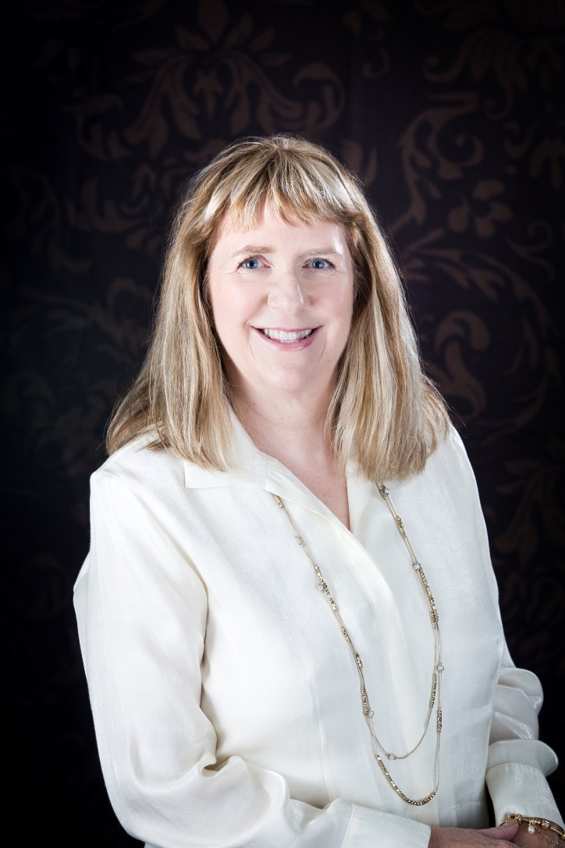
MELISSA R. RICH, PH.D.

info@drmelissarich.com / 405-919-9246 / www.drmelissarich.com

Keynote Proposal
“Starve the Anxiety, Feed the Joy”

Abstract
Everyone experiences anxiety. At times it can become ingrained and habitual due to old, negative, toxic patterns.

I use my 40+ years of experience as a Family Therapist, University Professor and Consulting Hypnotist to teach people how to stop feeding their anxiety by transforming their thoughts, habits and beliefs into positive, empowering ones so they starve their anxiety and begin to feed their joy.

“Our students found her engaging, relatable, funny, and knowledgeable about the subject matter. Our RA’s have already asked if she could come back next year as a presenter! I highly recommend Dr. Rich to anyone who is looking for a public speaker who is knowledgeable about her area of expertise and someone who is very relatable at the same time.”

Chris Green, MA, Resident Director, Independence Village, University of Mary Hardin-Baylor

Learning Objectives
1 – Learn 3 easy ways to starve your anxiety, by changing habits you already have.
2 – Discover 3 quick tools that help feed your joy, improve your health and increase your energy.
3 – Understand what God says about anxiety and get 3 ways to claim his help in overcoming worry.

References
Carol Fischer Rogers, VP of Client Development, Rytech Restoration, Inc. 254-644-0308, cfischer-rogers@rytechinc.com

Lou Ann Olson, Instructional Specialist for Federal Programs, Retired, Waco, Texas,
254-744-8665, lolson733@gmail.com

